Sara khan

55256

Task 1Write a program to declare an array of String and print all its elements using a for loop.

package a;

/\*\*

\*

\* @author Riphah

\*/

public class A {

public static void main(String[] args) {

String[] s = {"copy", "book", "pencil"};

for (int i = 0; i < s.length; i++) {

System.out.println(s[i]);

}

}

}

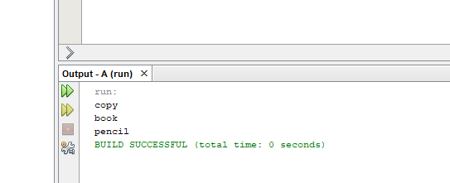

Task 2Create a program that checks if a given number is odd or even using if-else statements.

package b;

/\*\*

\*

\* @author Riphah

\*/

public class B {

public static void main(String[] args) {

int number = 5;

if (number % 2 == 0) {

System.out.println(number + " is even.");

} else {

System.out.println(number + " is odd.");

}

}

}

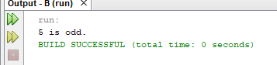

Task 3Implement a while loop to print even numbers from 1-20.

package c;

/\*\*

\*

\* @author Riphah

\*/

public class C {

public static void main(String[] args) {

int number = 1;

while (number <= 20) {

if (number % 2 == 0) {

System.out.println(number);

}

number++;

}

}

}

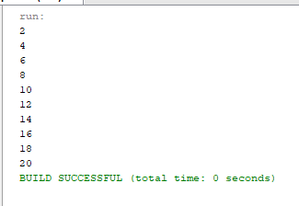

Task 4Write a program to print the following pattern using nested loops:

\* \* \* \* \* \*

\* \* \* \* \* \*

\* \* \* \* \* \*

\* \* \* \* \* \*

package d;

/\*\*

\*

\* @author Riphah

\*/

public class D {

public static void main(String[] args) {

int r = 4;

int c = 6;

for (int i = 0; i < r; i++) {

for (int j = 0; j < c; j++) {

System.out.print("\* ");

}

System.out.println();

}

}

}

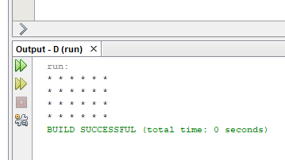

Task 5

Write a program to calculate the factorial of a hard-coded number using a while loop.

public class E {

public static void main(String[] args) {

int n = 5;

int fl = 1;

int i = 1;

while (i <= n) {

fl \*= i;

i++;

}

System.out.println("Factorial of " + n + " is " + fl);

}

}

